INTRODUCTION TO CYBERSECURITY

BASIC COMPUTER HARDWARE
TASK1: Open your computer or laptop and take a clear photo or screenshot of the System Information or About page that shows your processor (CPU), RAM, and storage details.
- Turn on the computer or laptop.
- Press Windows + I to open Settings.
- Click on System.
- Select About.
- In the Device specifications section, check:
- Processor (CPU)
- Installed RAM
5.To check storage, go to Settings → System → Storage.
6.Take a clear screenshot showing the system information.
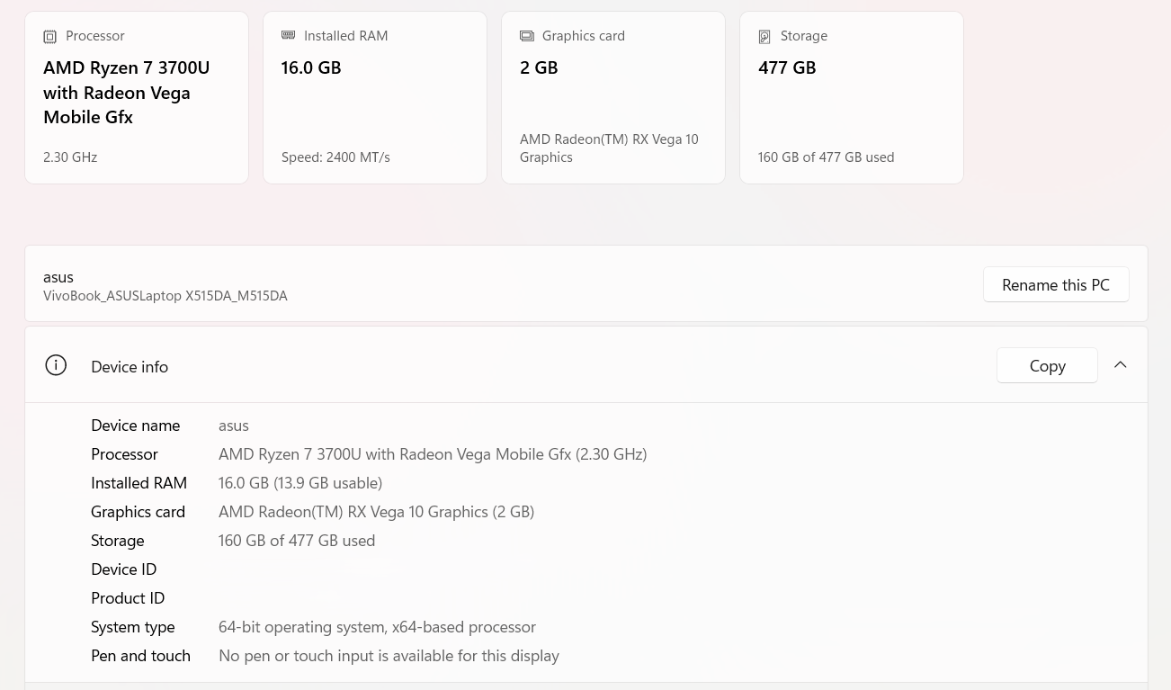
TASK2: Draw and label a diagram (on paper or digitally) showing the main hardware components inside a computer cabinet, including CPU, RAM, motherboard, hard drive/SSD, power supply, and at least two ports (USB, HDMI, etc.).
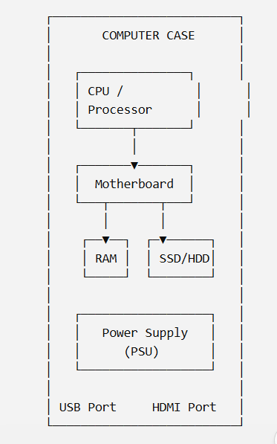
TASK3: List the hardware components you would check or upgrade to make your laptop run faster for gaming or video editing, and explain in one line why each upgrade helps.<br><br><em><strong>Hint:</strong> Think about RAM, SSD, GPU, and cooling.</em>
Hardware | Why I Would Upgrade It
RAM | More RAM helps run games and editing software smoothly.
SSD | An SSD makes Windows, games and applications load faster.
GPU | A better GPU improves gaming performance and video rendering.
Cooling System | Better cooling helps prevent overheating during heavy use.

TASK4: Research the difference between SSD and HDD storage, then write a short comparison (3 points) explaining which one is better for a student who wants fast boot times and why.
Point | SSD | HDD
Speed | Much faster | Slower
Technology | Uses flash memory and has no moving parts | Uses magnetic disks and moving parts
Boot Time | Provides faster Windows boot and application loading | Takes more time to boot and load applications

SSD is better for a student who wants fast boot times. It starts Windows faster, opens applications quickly, and generally gives the computer a more responsive feel.

